**AWS CLOUD PRACTITIONER**

**Section 6: ELB (Elastic Load Balancing) & ASG (Auto Scaling Groups):**

* + 1. **High Availability, Scalability, Elasticity**

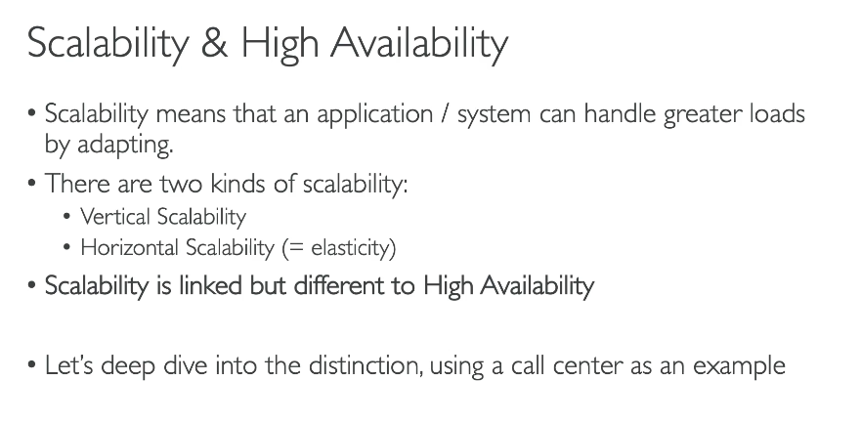

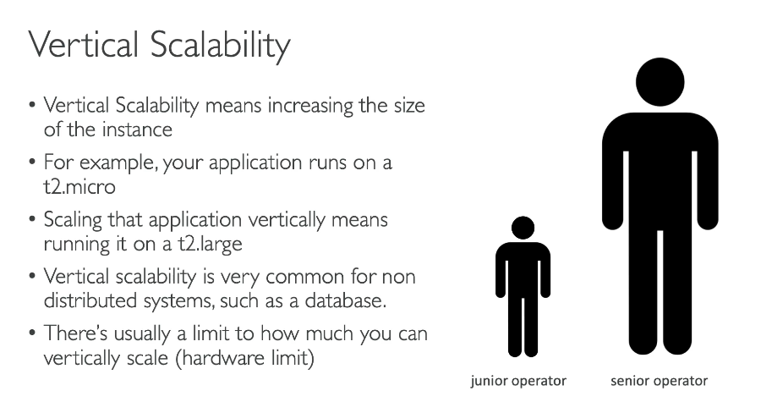

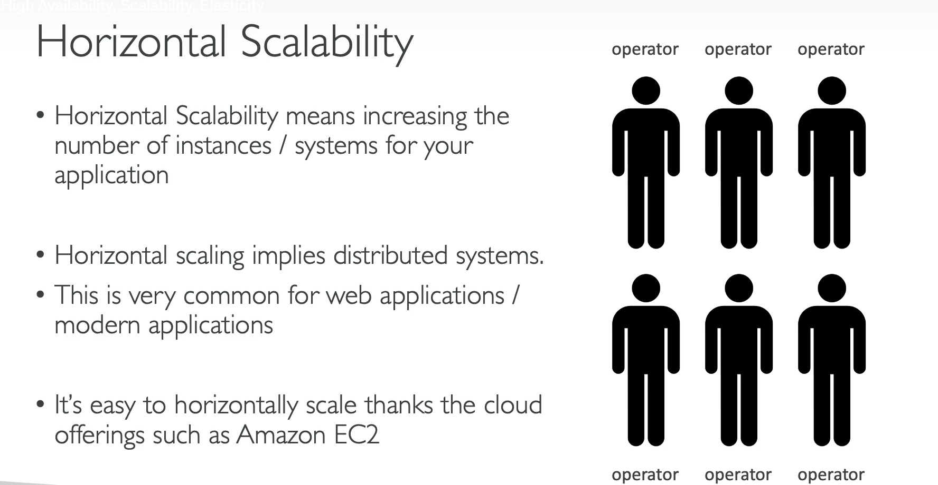

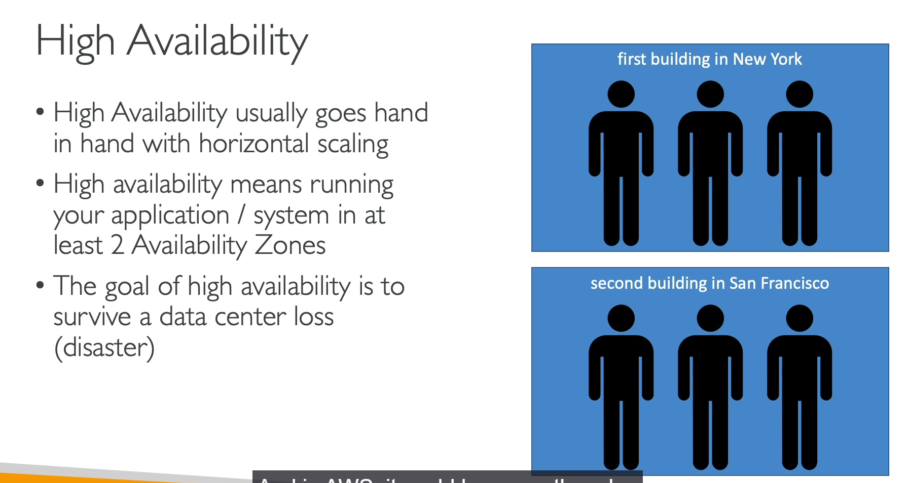

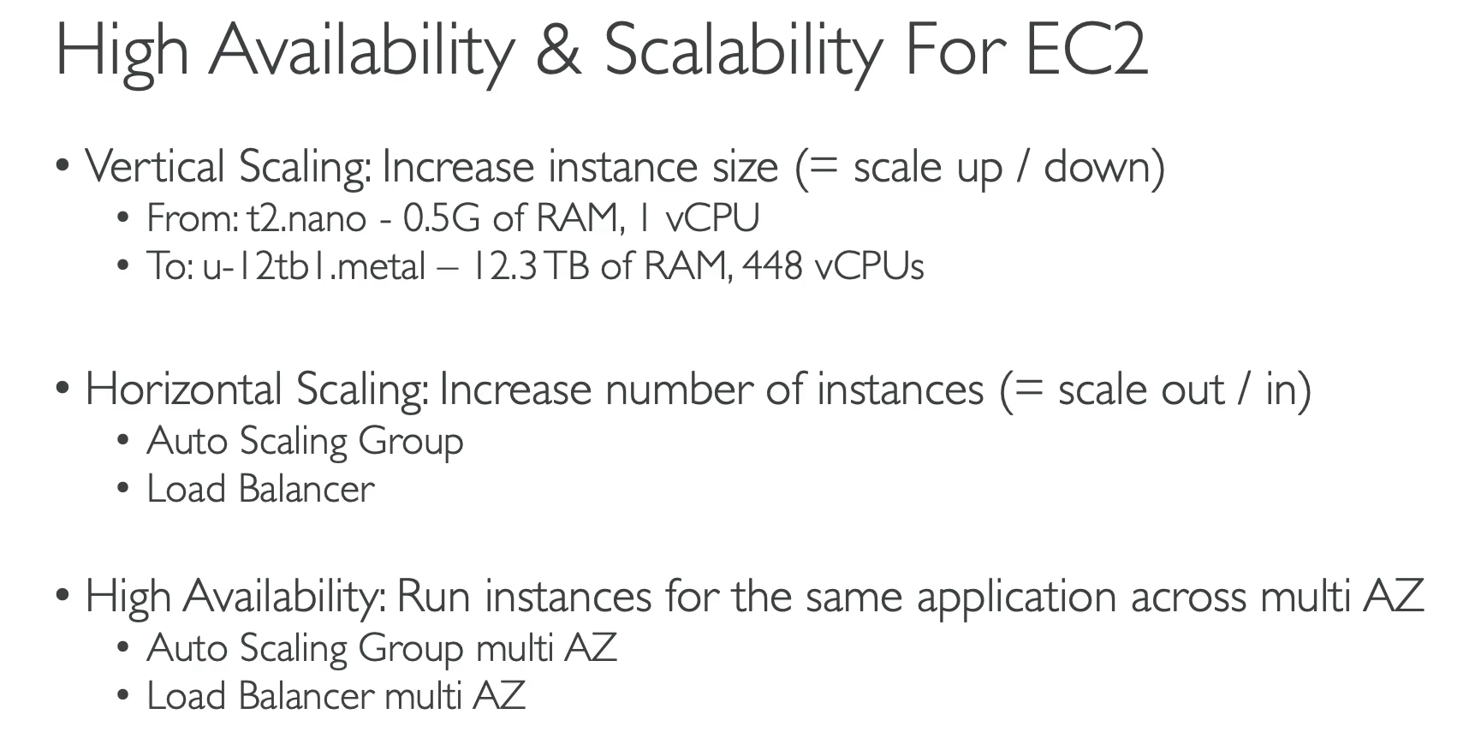

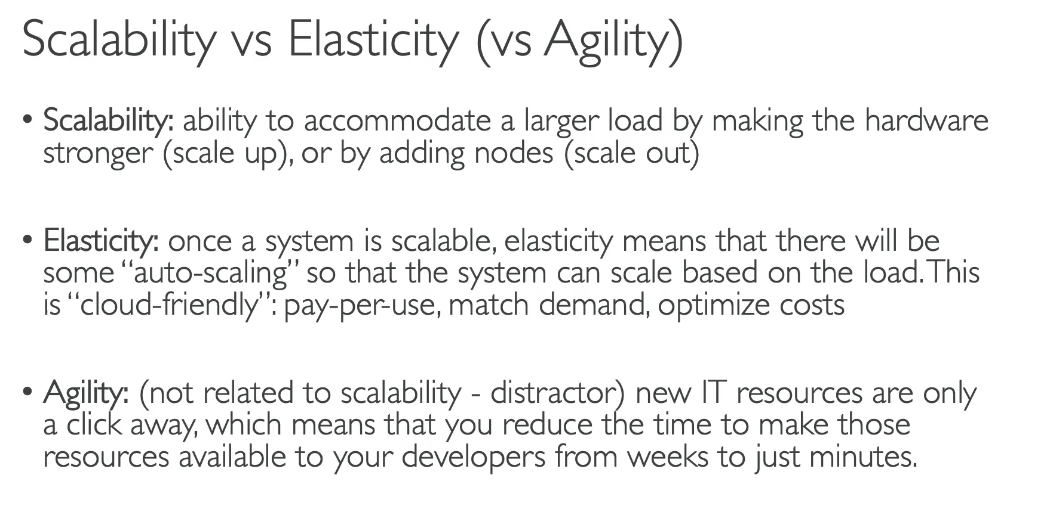

**1. Scalability**

Scalability is the ability of a system to handle increased load by adapting its resources. There are two main types of scalability:

* **Vertical Scalability (Scaling Up/Down)**: This means increasing the size of an EC2 instance.
  + **Analogy**: Upgrading a junior call center operator to a senior operator who can handle more calls.
  + **AWS Example**: Changing an instance from t2.micro to t2.large.
  + **Use Case**: Common for non-distributed systems like a database, but there are limits based on hardware size.
* **Horizontal Scalability (Scaling Out/In)**: This means increasing the number of instances to handle a greater load.
  + **Analogy**: Adding more operators to a call center.
  + **AWS Example**: Using an **Auto Scaling Group** to launch more EC2 instances.
  + **Use Case**: The standard approach for modern, distributed web applications.

**2. High Availability**

High Availability (HA) ensures that an application remains operational even if a data center or a specific hardware component fails.

* **Definition**: Running your application across at least two **Availability Zones (AZs)**.
* **Analogy**: Having a call center in both New York and San Francisco, so if one city has a power outage, the other can still handle calls.
* **AWS Tools**: Leveraged by a multi-AZ **Auto Scaling Group** and a **Load Balancer**, which distribute traffic across instances in different AZs.

**3. Elasticity and Agility**

These are two related but distinct concepts in cloud computing:

* **Elasticity**: This is the ability of a system to automatically scale in or out based on the current load.
  + **Benefit**: It ensures you only pay for the resources you are actively using, matching demand with supply. This is a core feature of the cloud.
* **Agility**: This is the ability to quickly and easily provision IT resources.
  + **Example**: Being able to launch a new server in minutes instead of weeks. Agility is about speed and flexibility, not directly about scalability. It's a key benefit of AWS but is distinct from elasticity and scalability.
    1. **Elastic Load Balancing (ELB) Overview:**

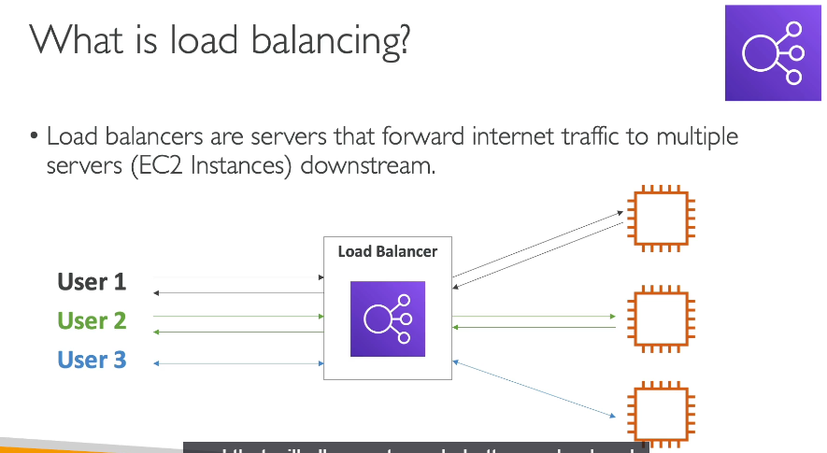

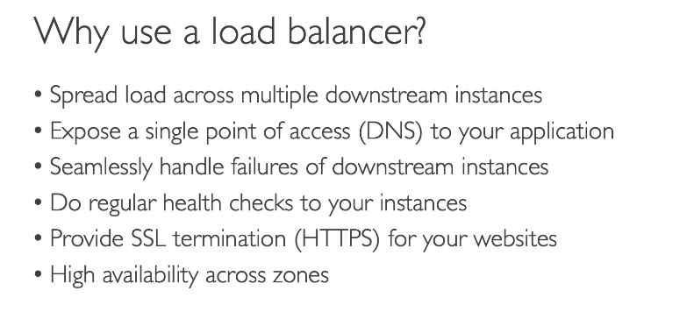

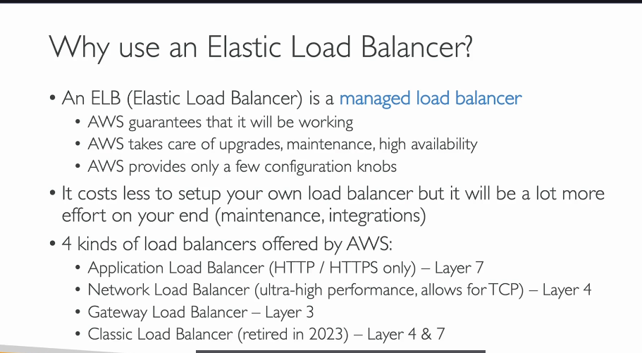

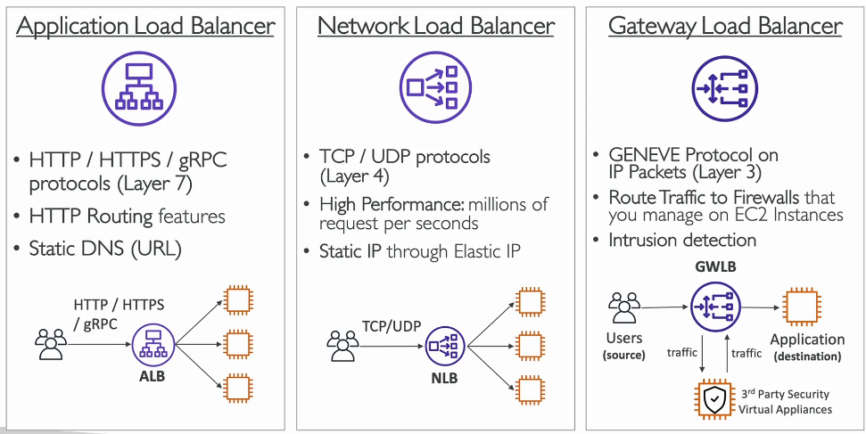

**What is an Elastic Load Balancer (ELB)?**

An **Elastic Load Balancer (ELB)** is a managed AWS service that automatically distributes incoming internet traffic across multiple backend servers (like EC2 instances). It's a key tool for achieving **elasticity** and **high availability** for your applications.

The load balancer is the single public entry point for your application. It forwards user requests to your instances, and the instances send the responses back through the load balancer.

**Benefits of Using an ELB**

* **Distributes Load**: Spreads traffic evenly across multiple EC2 instances to prevent any single instance from becoming overwhelmed.
* **Single Point of Access**: Provides a single, stable DNS hostname for your application, hiding the complexity of the underlying instances.
* **Handles Failures**: Automatically performs **health checks** on instances. If an instance is unhealthy, the load balancer stops sending traffic to it until it recovers.
* **High Availability**: Can distribute traffic across instances in multiple Availability Zones (AZs) to protect against a data center failure.
* **Managed Service**: AWS handles all the provisioning, maintenance, and scaling of the load balancer itself.

**Types of Load Balancers**

AWS offers four main types of load balancers, each designed for specific use cases.

**1. Application Load Balancer (ALB)**

* **Layer 7**: Operates at the application layer, handling **HTTP, HTTPS**, and gRPC traffic.
* **Routing**: Offers advanced routing features based on the content of the request, such as the URL path.
* **Use Case**: Ideal for modern web applications that require intelligent routing. It's often used for microservices.
* **Identifier**: Look for keywords like "HTTP," "HTTPS," or "content-based routing."

**2. Network Load Balancer (NLB)**

* **Layer 4**: Operates at the transport layer, handling **TCP** and **UDP** traffic.
* **Performance**: Known for its **ultra-high performance**, capable of handling millions of requests per second with extremely low latency.
* **Static IP**: Provides a **static IP address** through an Elastic IP, which is a significant advantage for some applications.
* **Use Case**: Perfect for high-performance, latency-sensitive applications like gaming servers, real-time streaming, and other high-volume workloads.

**3. Gateway Load Balancer (GWLB)**

* **Layer 3**: Operates at the network layer, handling **IP packets**.
* **Use Case**: Specifically designed for routing traffic to third-party **virtual security appliances** such as firewalls or intrusion detection systems (IDS). It acts as a transparent network gateway.
* **How it Works**: It intercepts traffic, routes it to your security appliances for inspection, and then forwards it to your application, all in a single flow.

**4. Classic Load Balancer (CLB)**

* **Legacy**: This is an older generation load balancer that is being phased out. It supports both Layer 4 and Layer 7 traffic. It's generally not a focus for current exams.
  + 1. **Application Load Balancer (ALB) Hands On:**

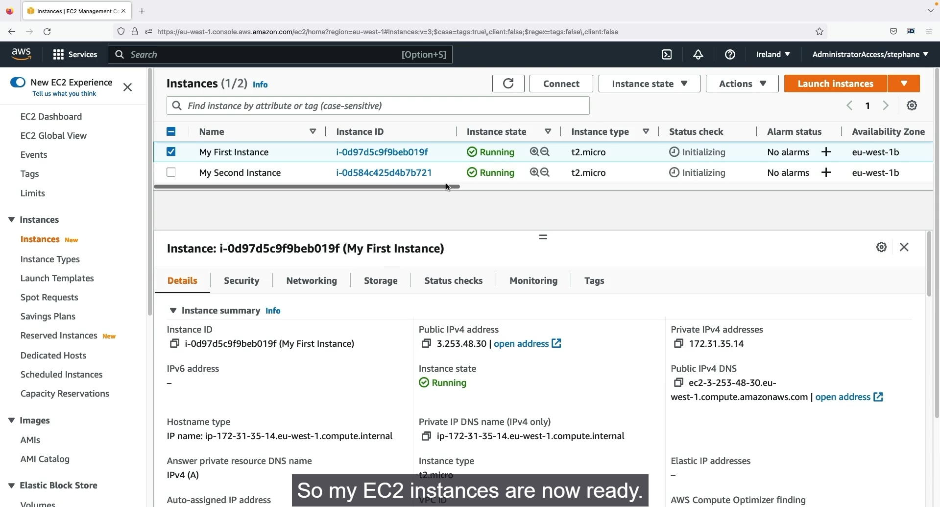

Step1: First for creating the Load balancer we want to launch the instance first. Create two or more instance and make them to run.

Step2: Now the instances are in running stage. SO, we can create the load balancer now.

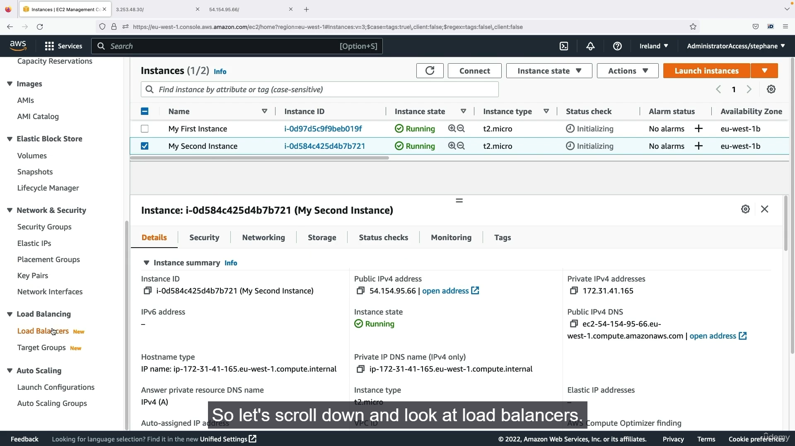

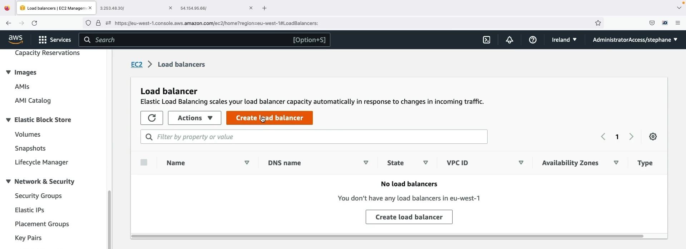

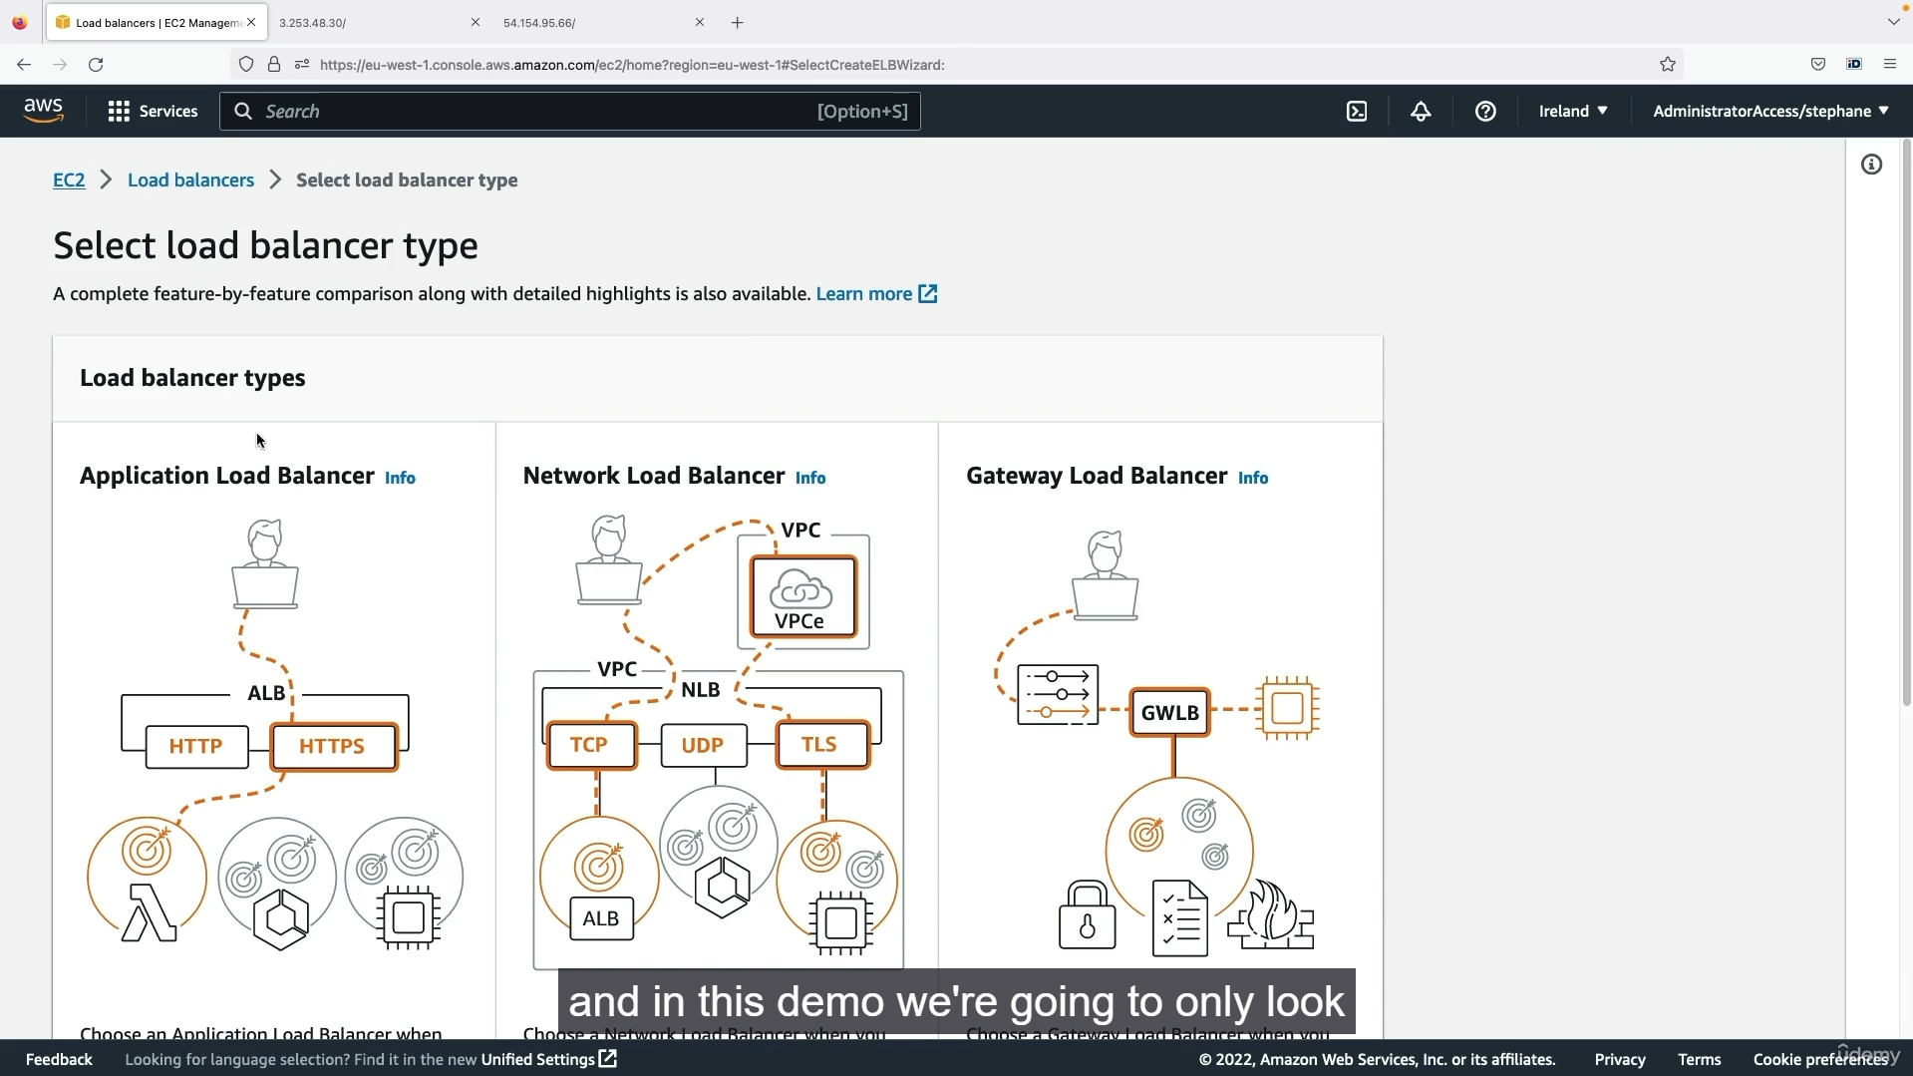

Step 1: Now we want to go to load balancer. Left side panel 🡪 Load Balancing 🡪 Create Load Balancer.

Step 2: Now enter the Load balancing settings 🡪 Chose which type of load balancer want to create.

Step 3: Now we are going to select the Application Load Balancer.

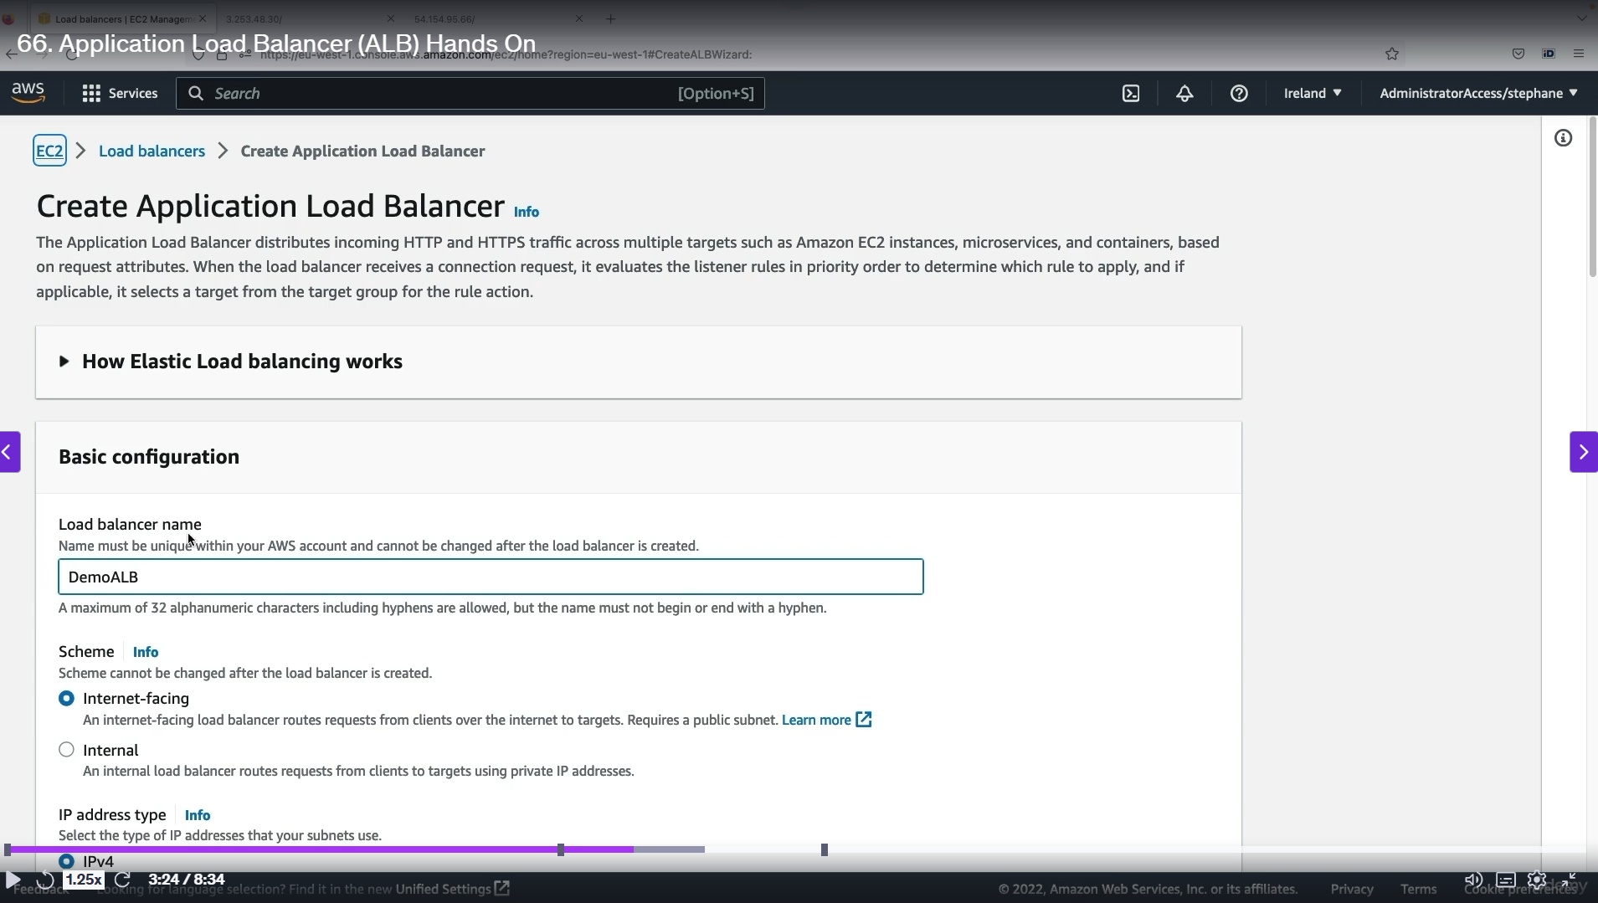

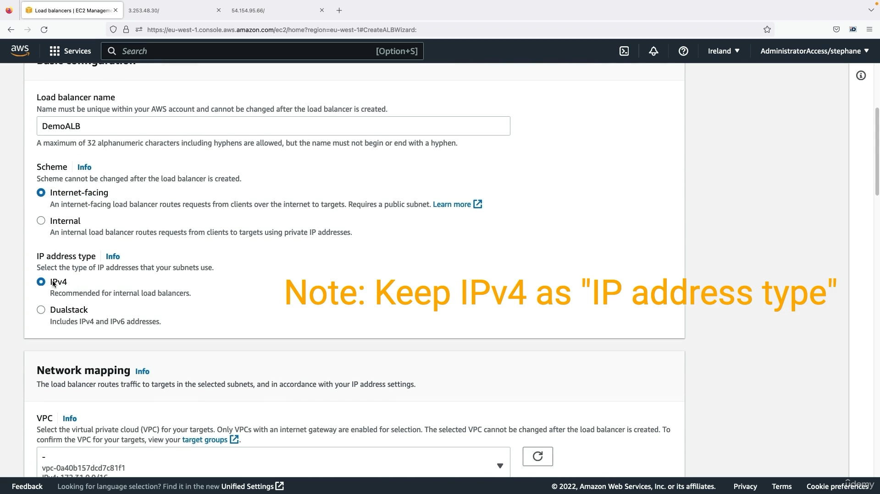

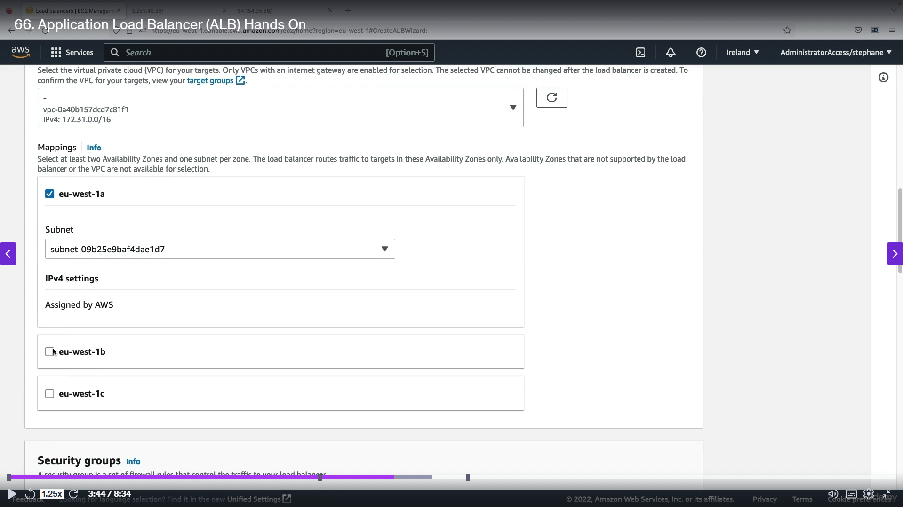  
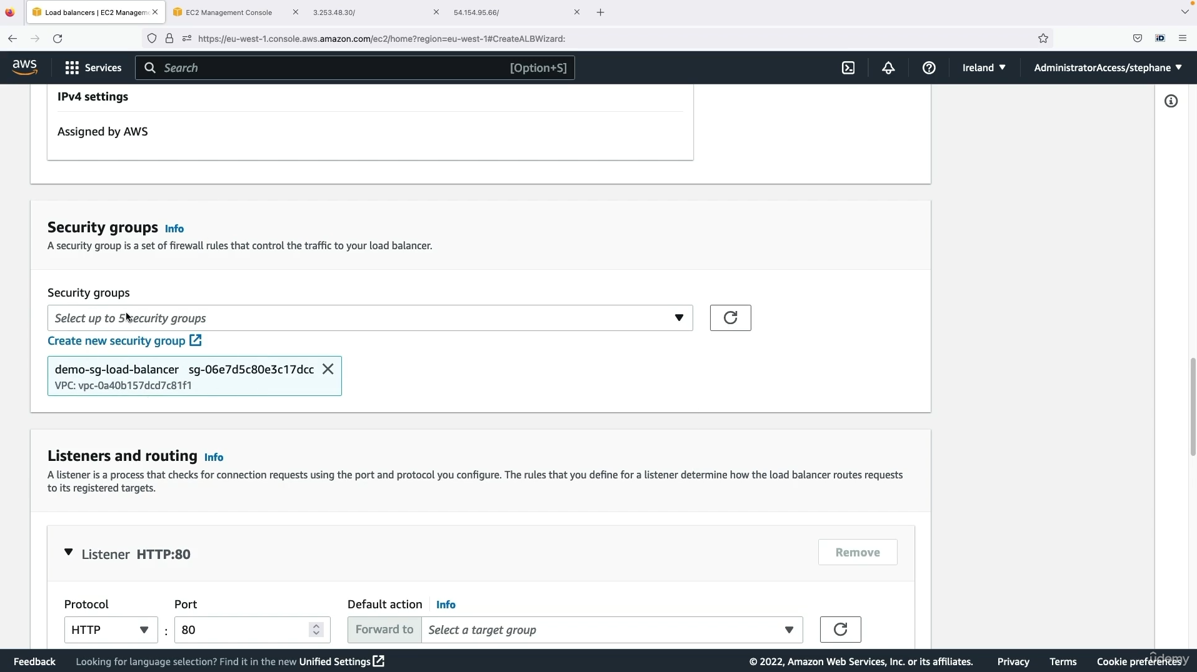

Step 1: Now we enter into auto load balancing settings.

Step 2: Enter the load balancer name 🡪 Select ip address as ipv4 🡪 Create a new security group or allow the existing one 🡪 Now we want to create listeners and routing.

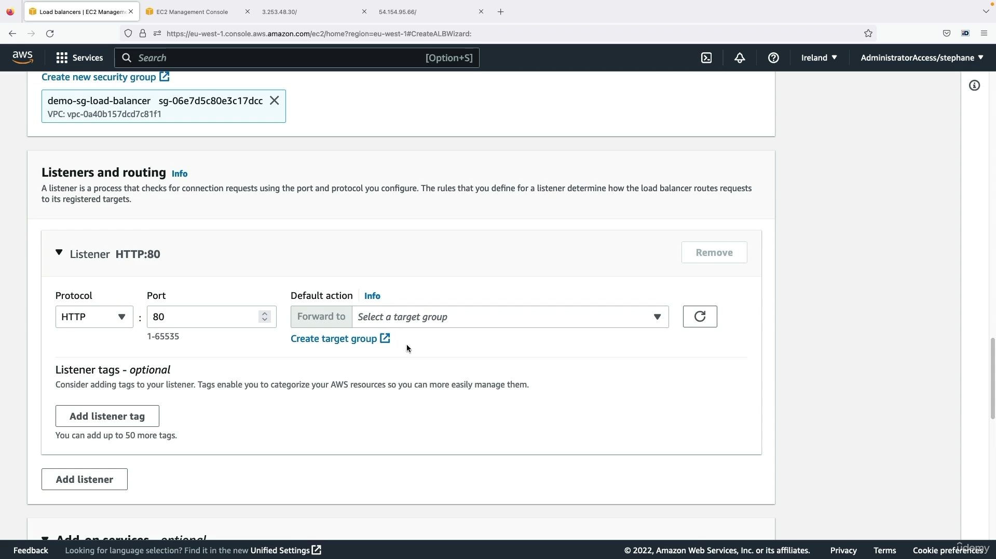

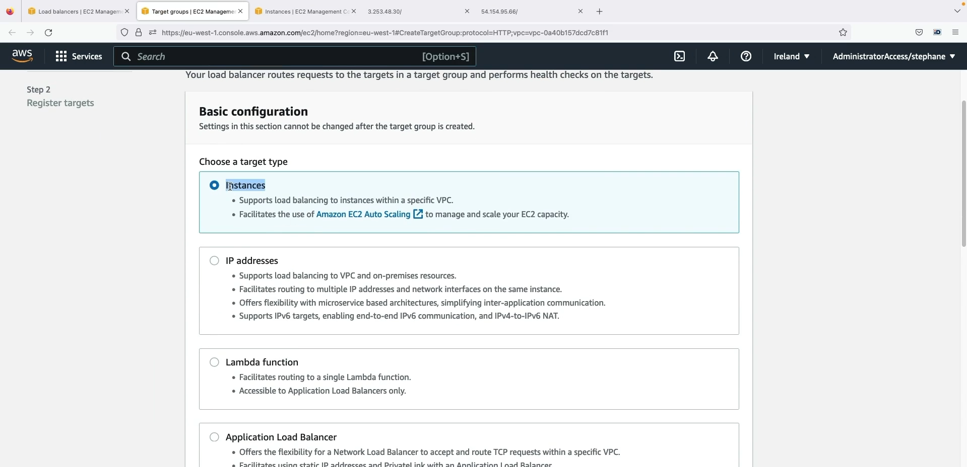

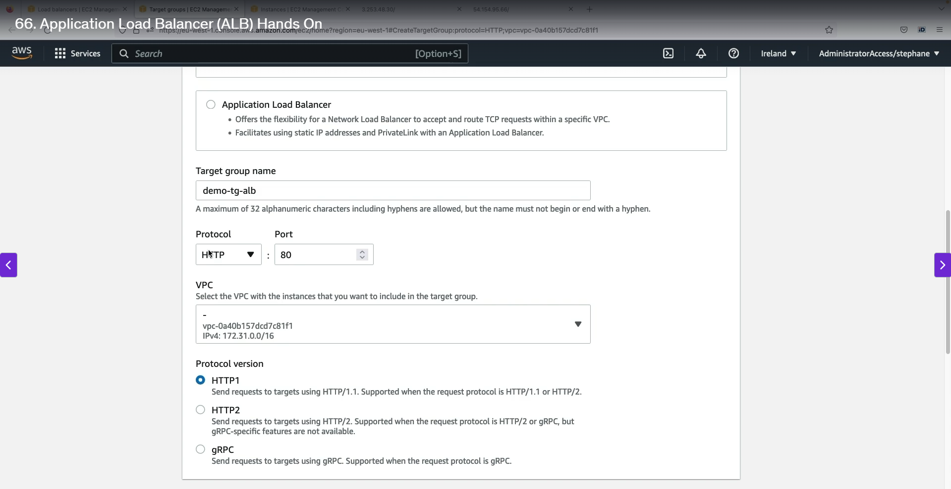

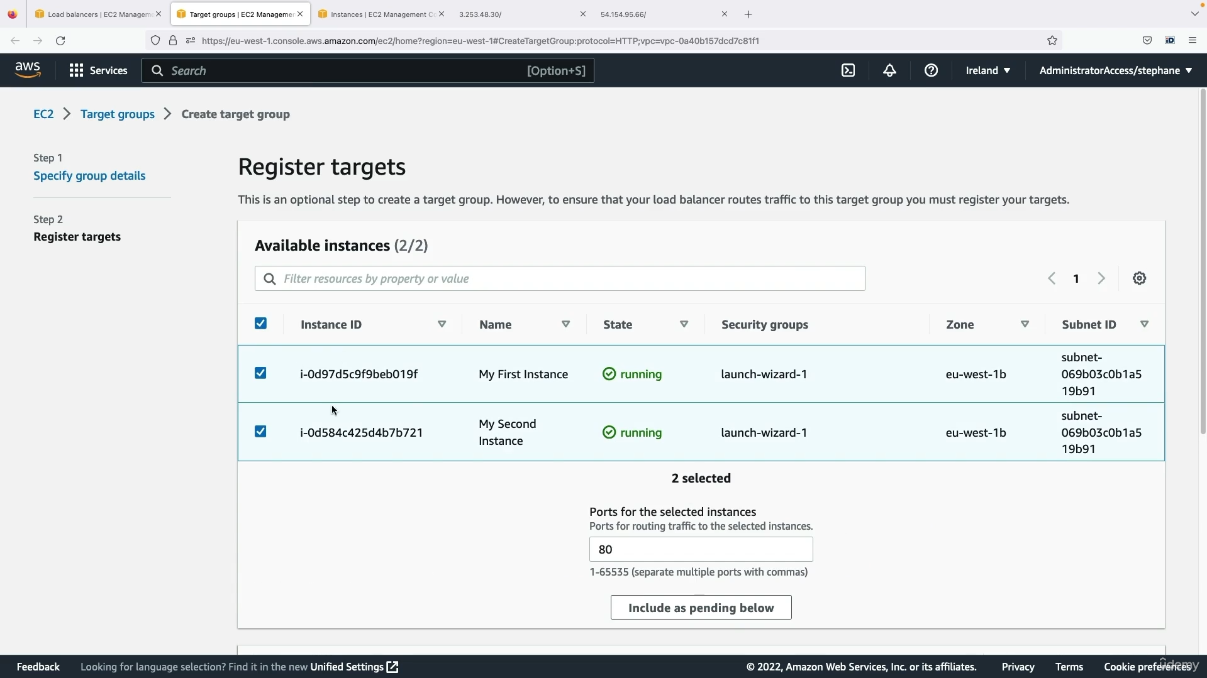

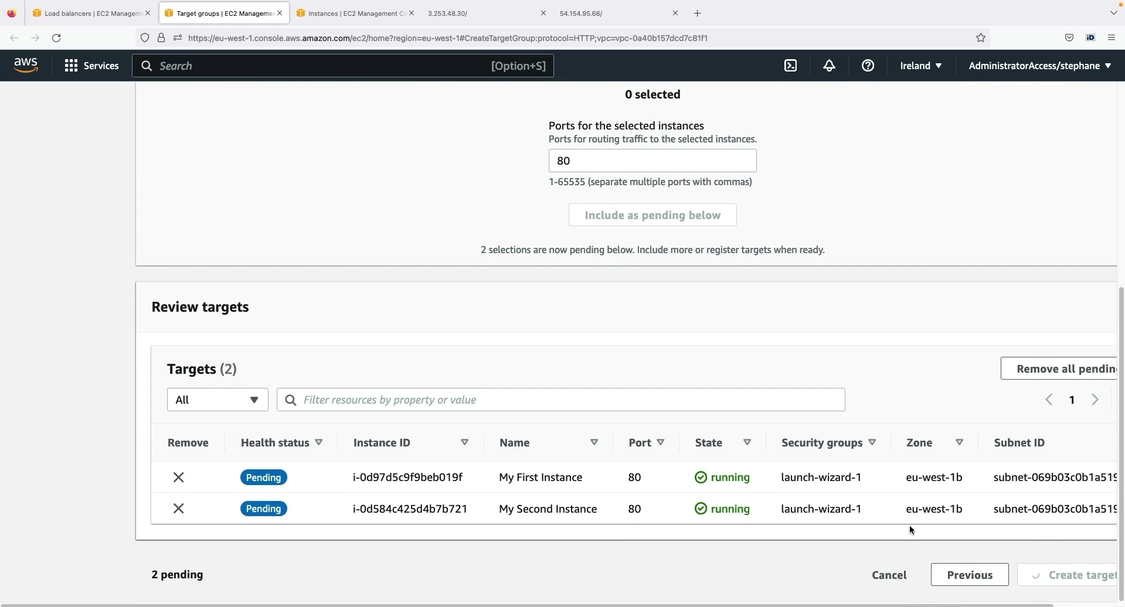

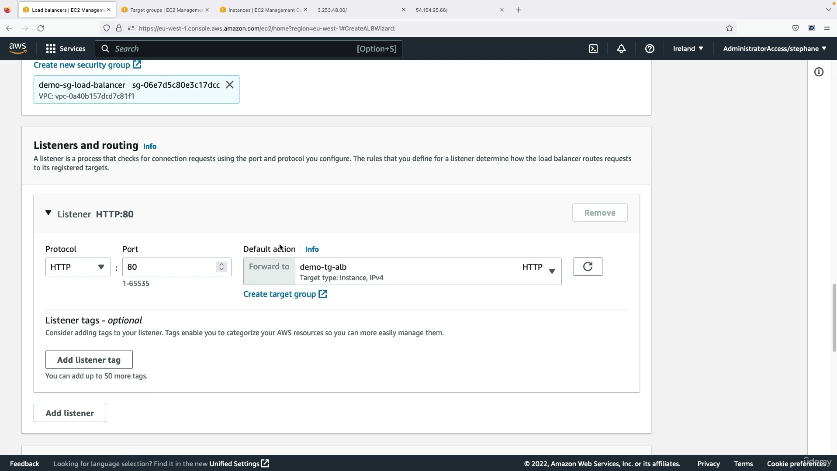

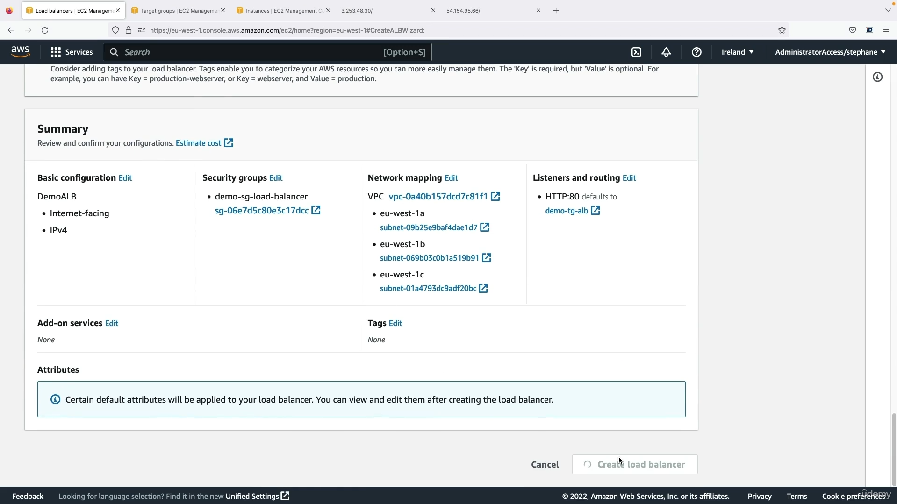

Step 1: Click Create target groups 🡪 Enter into settings 🡪 Choose which one want to group for balancing.

Step 2: Select register targets 🡪 select the instances for load balancing 🡪 click the include as pending below 🡪 finally create targets.

Step 3: The targets was created successfully.

Step 4: After in the load balancer setting 🡪 chose the target group which you created.

Step 5: Finally click 🡪 Create load balancer 🡪 load balancer created successfully.

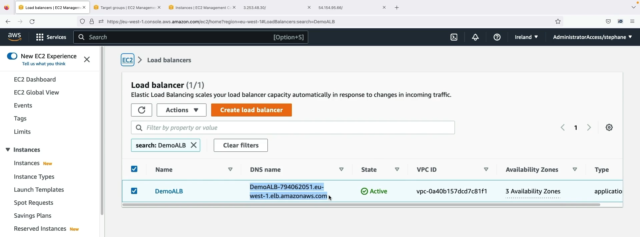

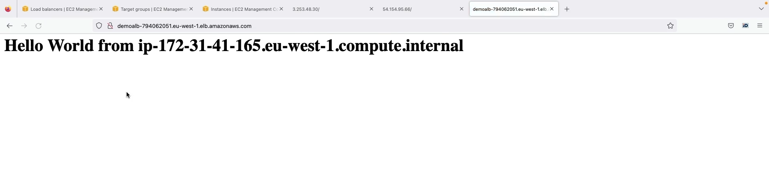

Step1 : After load balancer created successfully 🡪 state will be in active 🡪 copy DNS name 🡪 paste in browser 🡪 refresh for sometimes.

Step 2: You will see the incoming traffic will distributed among two instances as seen in above image.

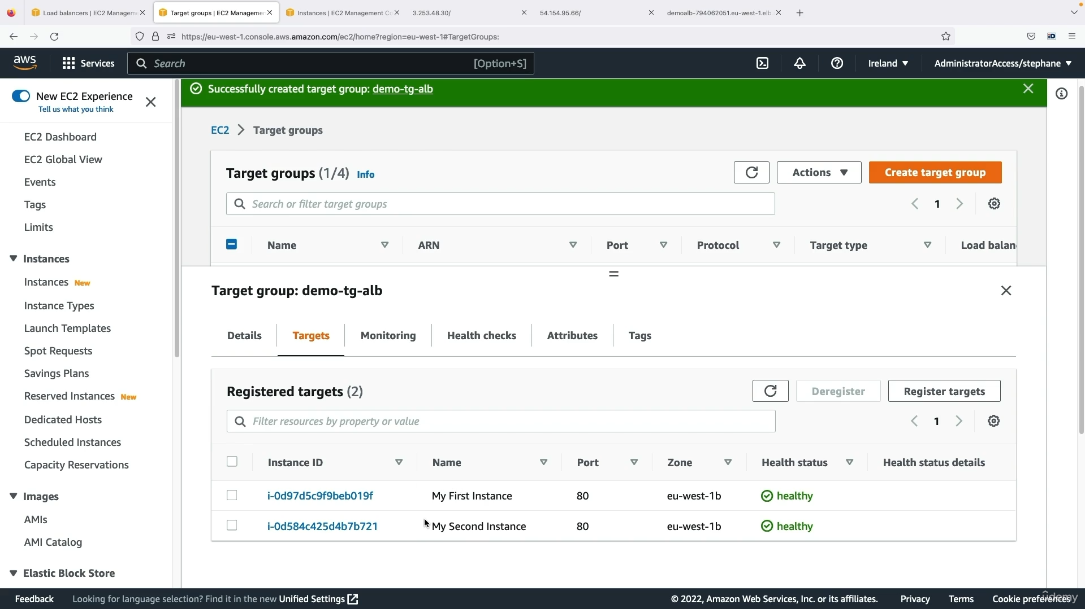

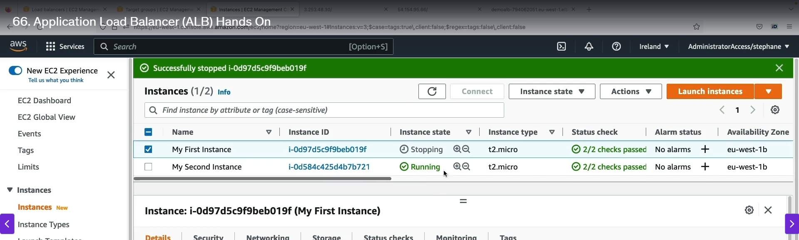

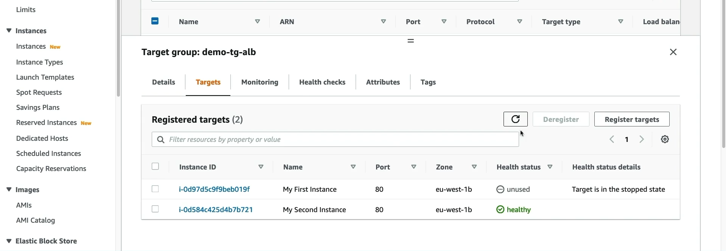

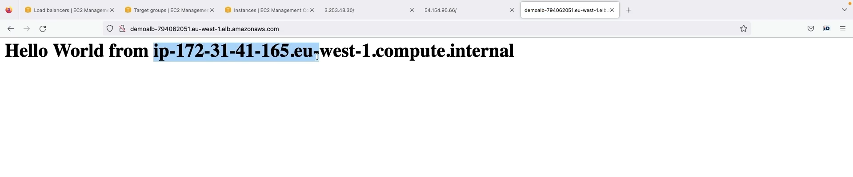

Step1: Go to targets groups 🡪 registered targets 🡪you will see two instances in healthy state which you selected in the above.

Step2: Stop one instances 🡪 check the target group 🡪 stopped instances health status 🡪 changed into unused.

Step3: Now copy the dns link 🡪 refresh many times 🡪 incoming traffic will go to only one instances which was running.

Step4: So, if we stopped instances 🡪 incoming traffic will not distributed.

* + 1. **Auto Scaling Groups (ASG) Overview:**

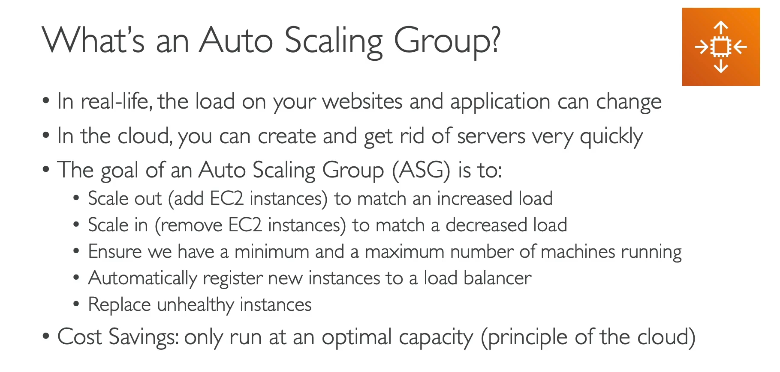

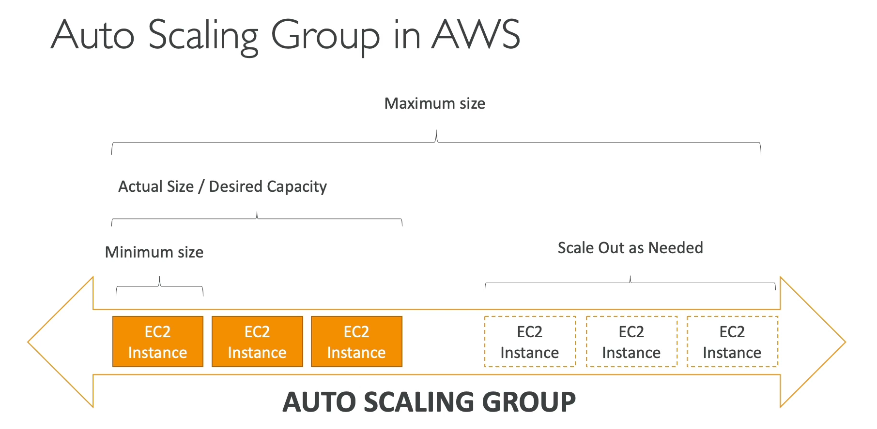

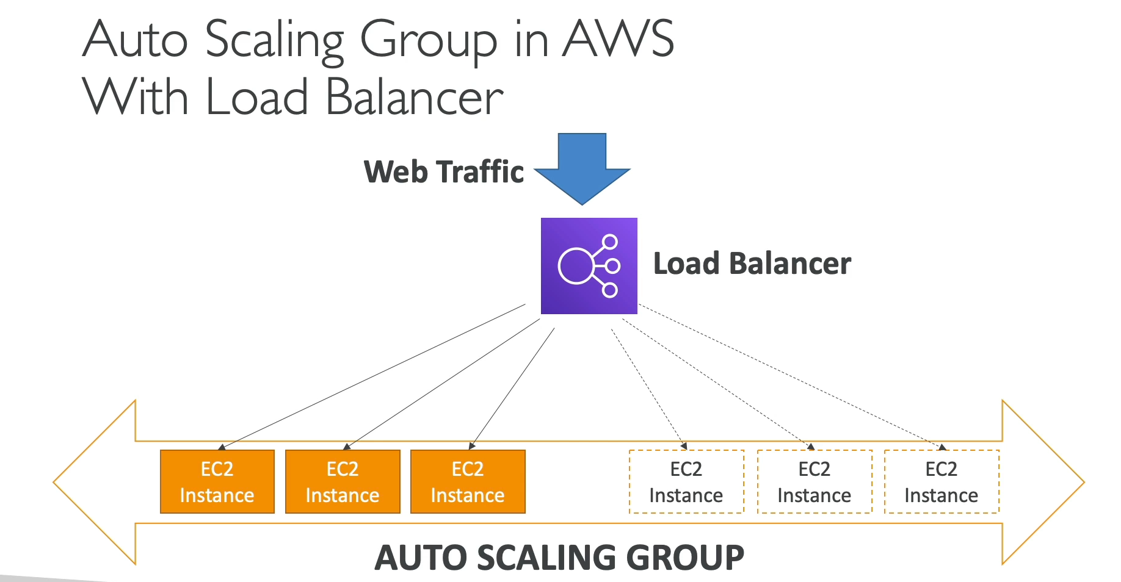

An Auto Scaling Group (ASG) in AWS automatically manages the number of EC2 instances for an application, ensuring optimal performance and cost efficiency.

**Core Concepts**

* **Elasticity:** An ASG helps an application adapt to varying traffic loads, a key principle of cloud computing. It **scales out** (adds instances) to handle increased demand and **scales in** (removes instances) during periods of low traffic.
* **Capacity Management:** You define a **minimum size** (the lowest number of instances), a **maximum size** (the highest number of instances), and a **desired capacity** (the target number of running instances).
* **Health Checks:** The ASG continuously monitors the health of its instances. If an instance becomes unhealthy, the ASG automatically terminates it and replaces it with a new, healthy one.

**Benefits**

* **High Availability:** By automatically replacing unhealthy instances and adding new ones to handle increased load, an ASG ensures your application remains available and responsive.
* **Cost Savings:** It helps optimize costs by only running the necessary number of instances at any given time, preventing you from over-provisioning resources.
* **Load Balancer Integration:** ASGs work seamlessly with a load balancer. When a new instance is launched, it's automatically registered with the load balancer, which then starts distributing traffic to it. When an instance is terminated, it's automatically deregistered.

**How It Works**

1. **Define Parameters:** You set the minimum, maximum, and desired number of EC2 instances for your application.
2. **Monitor Load:** The ASG monitors a chosen metric (like CPU usage) to determine if it needs to scale.
3. **Scale Out:** If the load increases and exceeds a set threshold, the ASG adds new EC2 instances (up to the maximum size) to handle the demand. These new instances are automatically registered with the load balancer.
4. **Scale In:** If the load decreases, the ASG removes instances (down to the minimum size) to save costs. These instances are automatically deregistered from the load balancer.
5. **Maintain Health:** If an instance fails a health check, the ASG terminates it and launches a replacement to maintain the desired capacity.
   * 1. **Auto Scaling Groups (ASG) Hands On:**

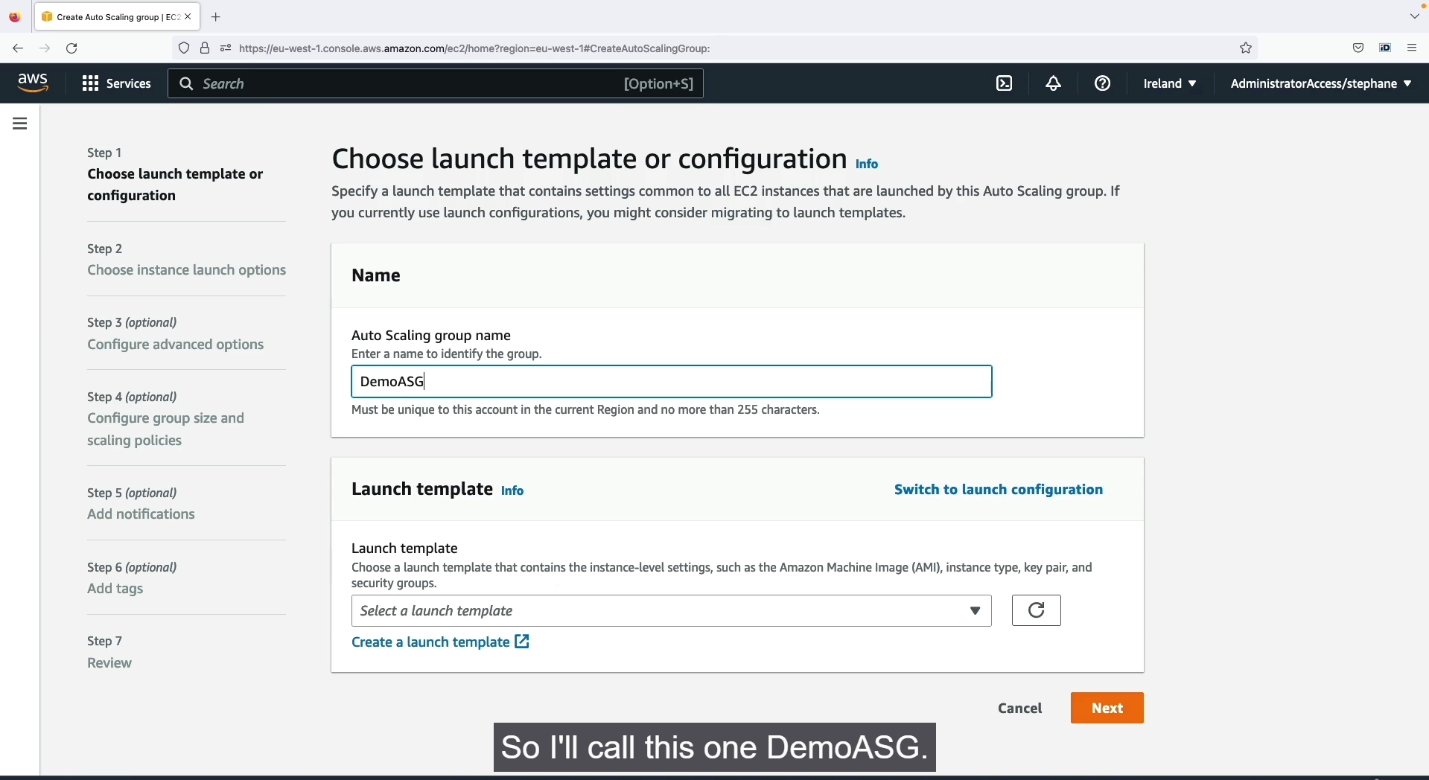



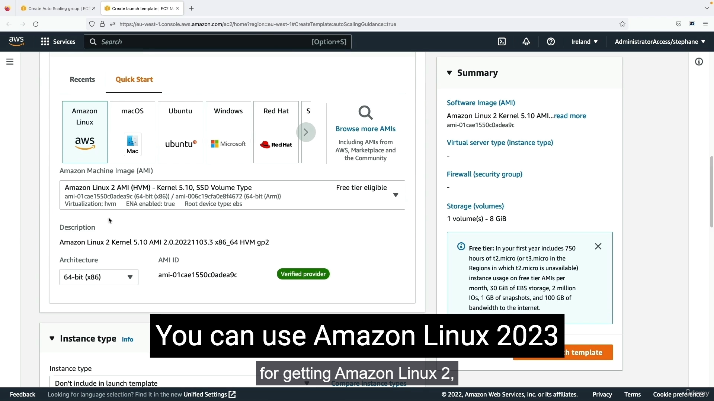

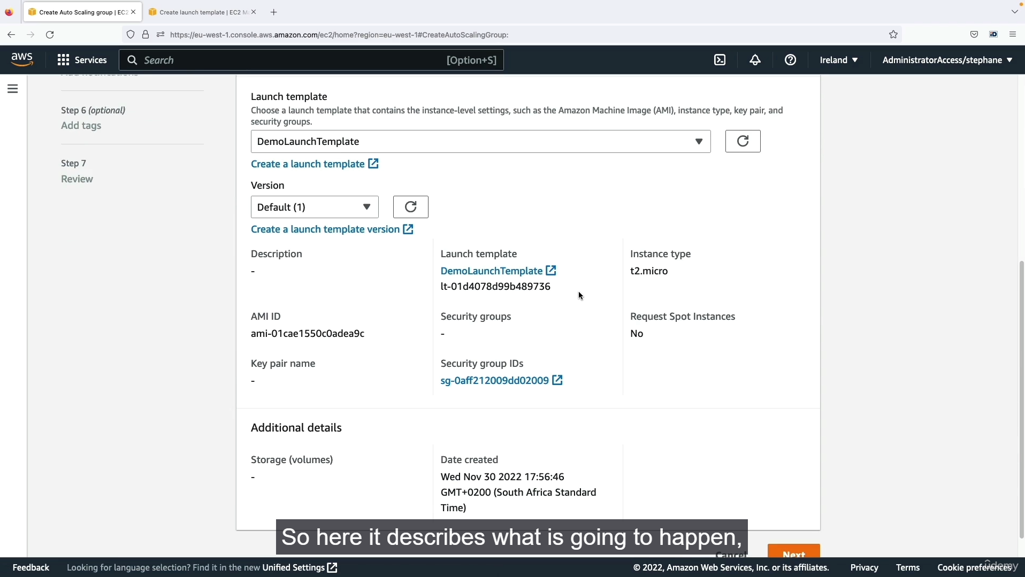

Step1 Left side panel 🡪 Auto scaling group 🡪create auto scaling group 🡪 Enter into the ASG setting page.

Step2: Enter the ASG name 🡪 select create launch template 🡪 In this step you will create the instances as same as before 🡪 because if we created here means the ASG will create the instances for auto scaling with these configurations.

Step 3: You can choose the launch the launch template which you created. 🡪 after that click next.

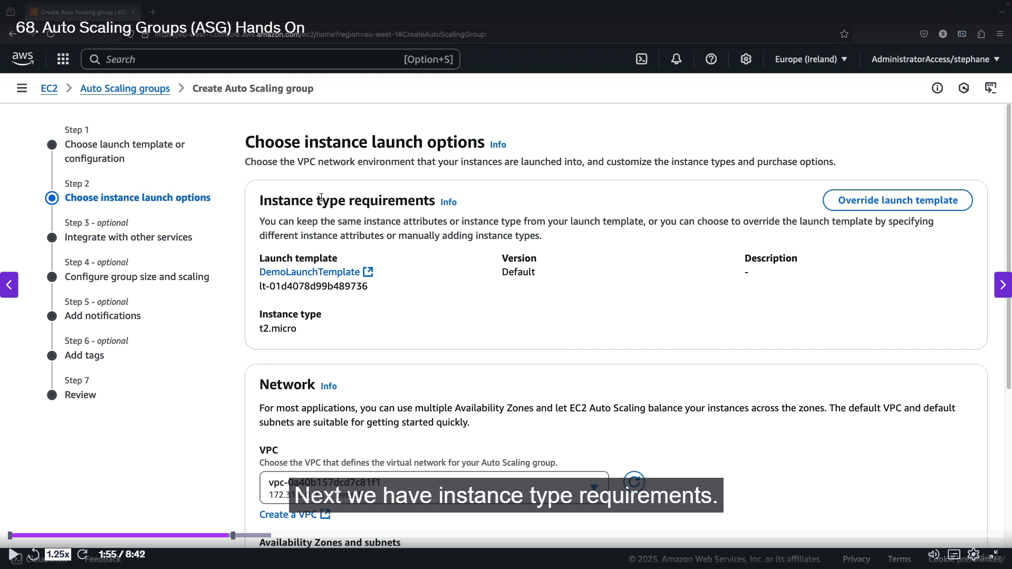

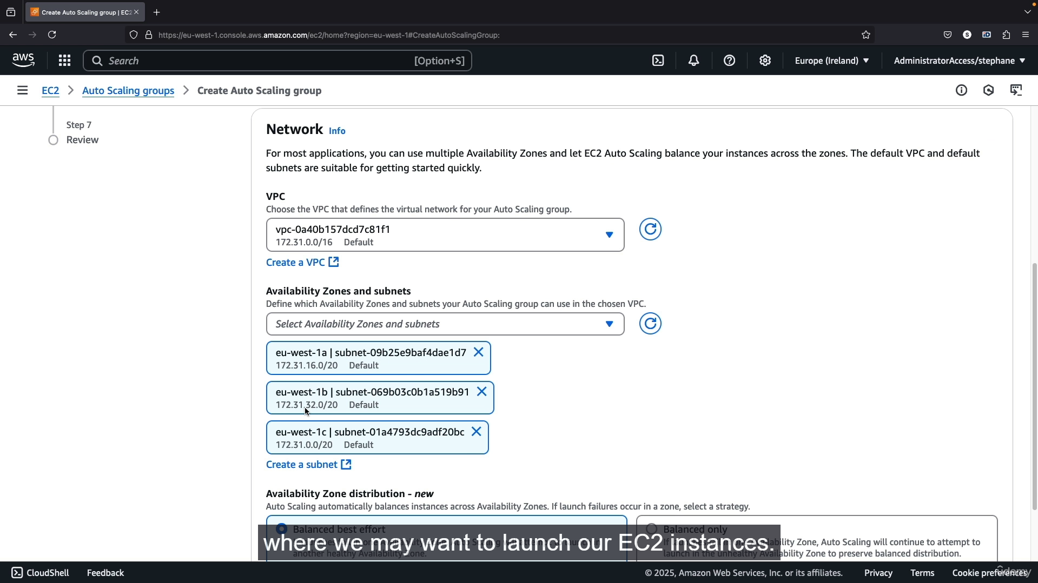

Step1 : In this step, we see 🡪 launch template overview 🡪 and network settings 🡪 select and map to all the AZs.

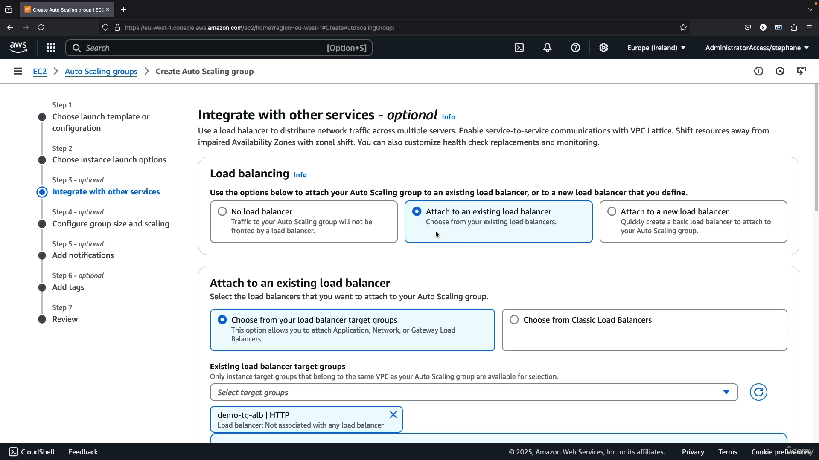

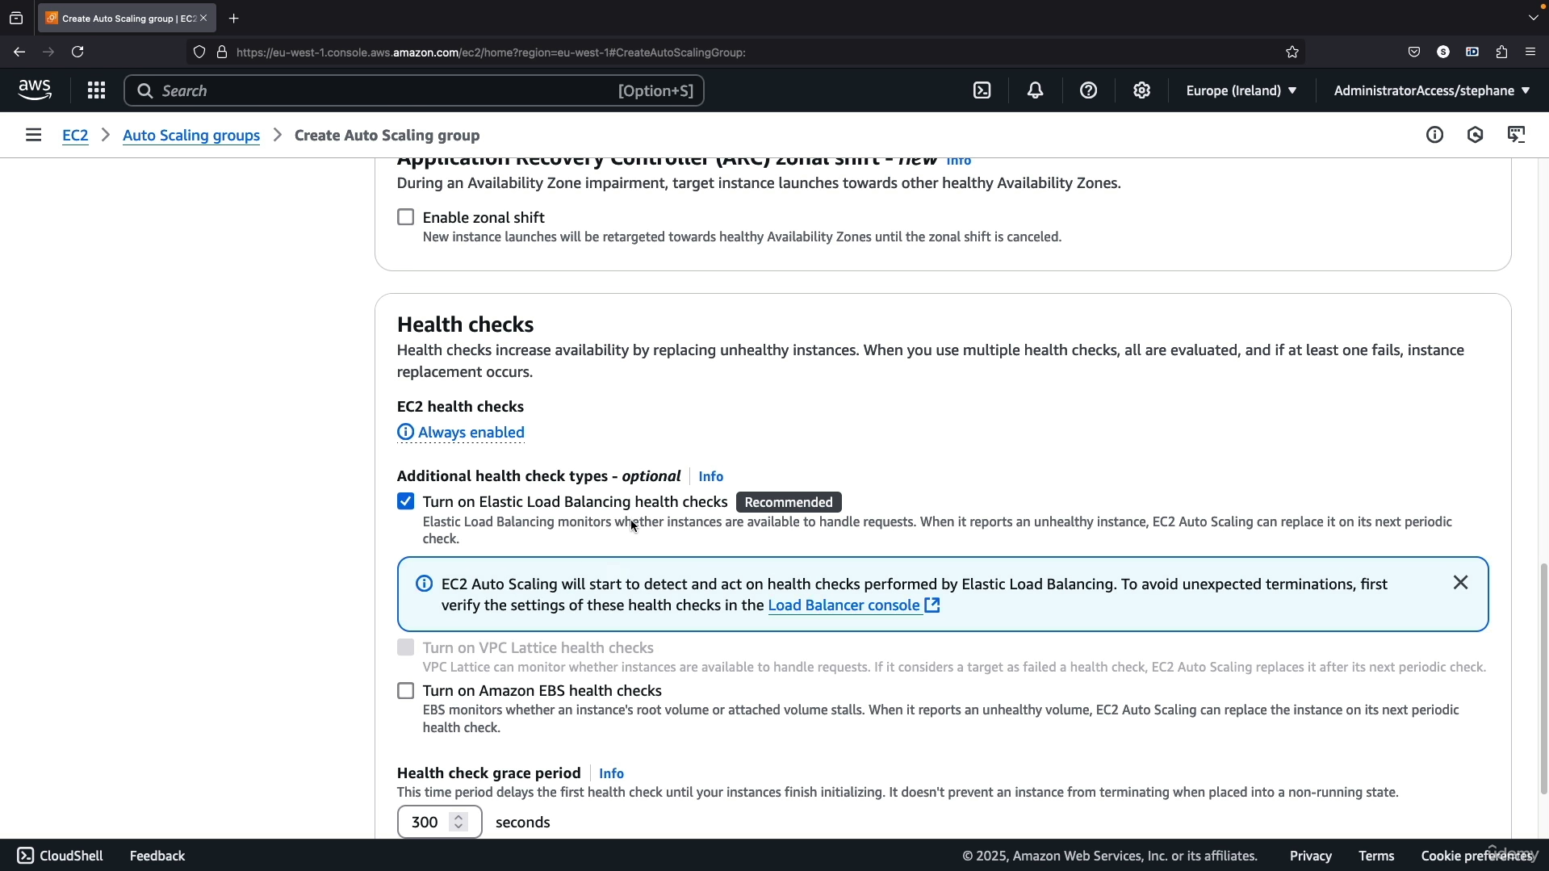

Step1: Here we will select the load balancing template 🡪 Because it is used to distribute the incoming traffic 🡪 Choose the option and fill according to that 🡪 select the load balance name.

Step 2: Next health check 🡪 select the turn on EBS health check 🡪 because by mistake any instances terminated 🡪 and health check state becomes unused 🡪 ASG will create a new instances with the same config we defined in launch template.

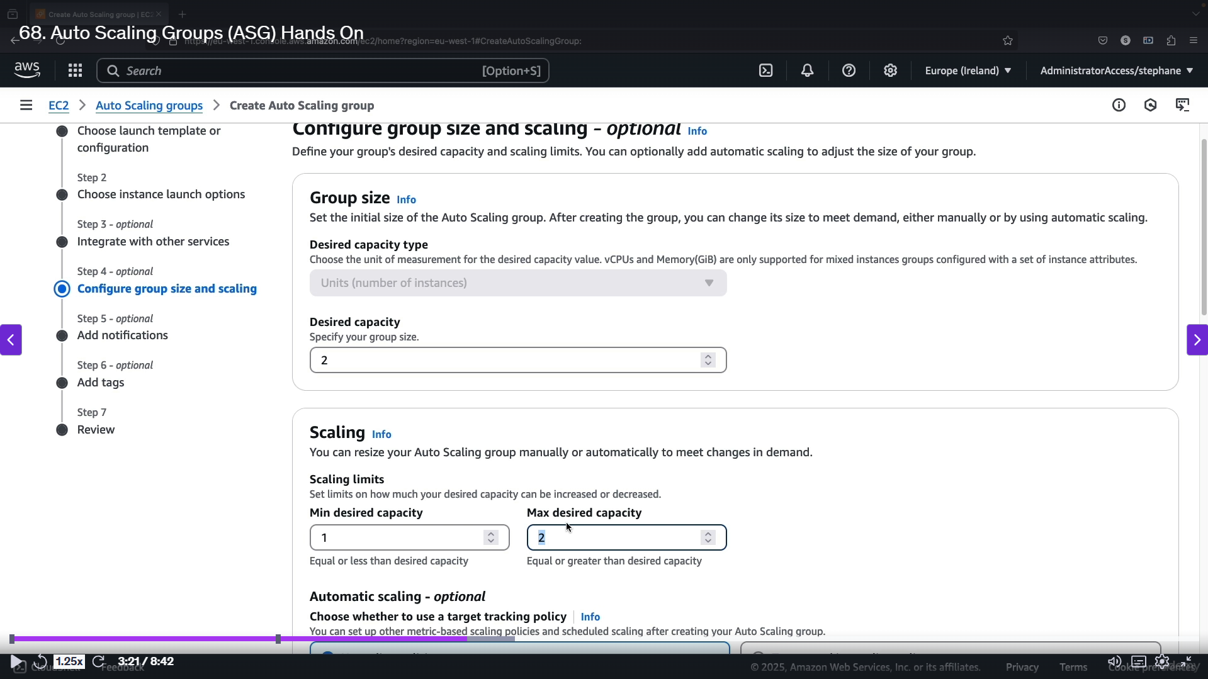

Step1: In this step we will define how many instances want for sacling 🡪 min and max instances 🡪 desired capacity of the ASG.

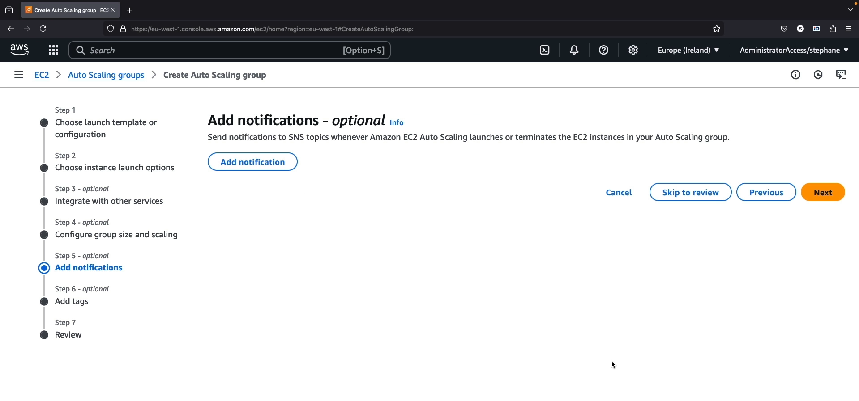

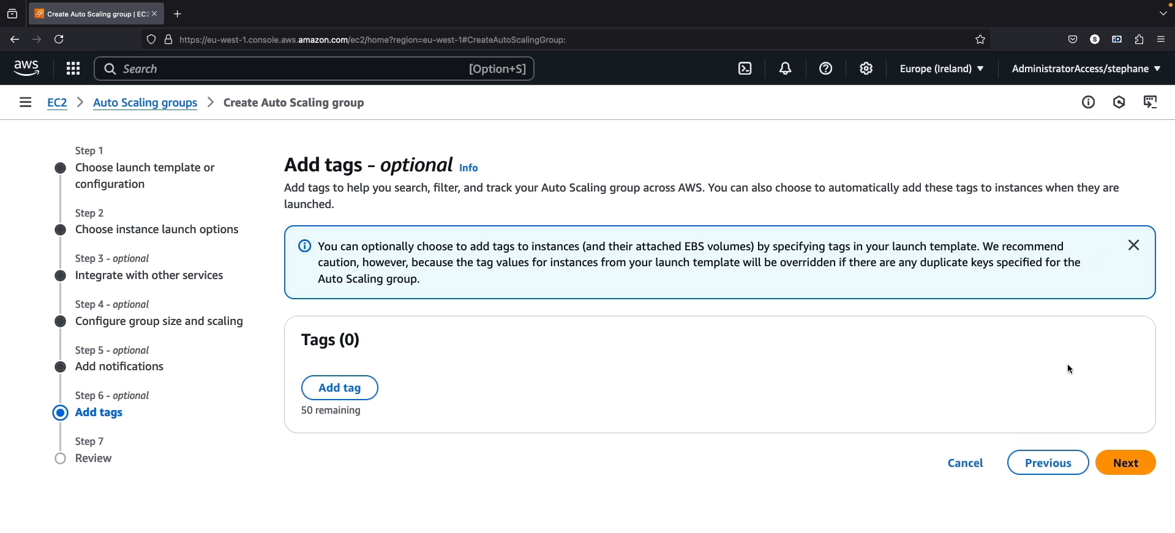

Step1: These are optional step 🡪 notifications and tags 🡪 if you want you can set 🡪 or click next.

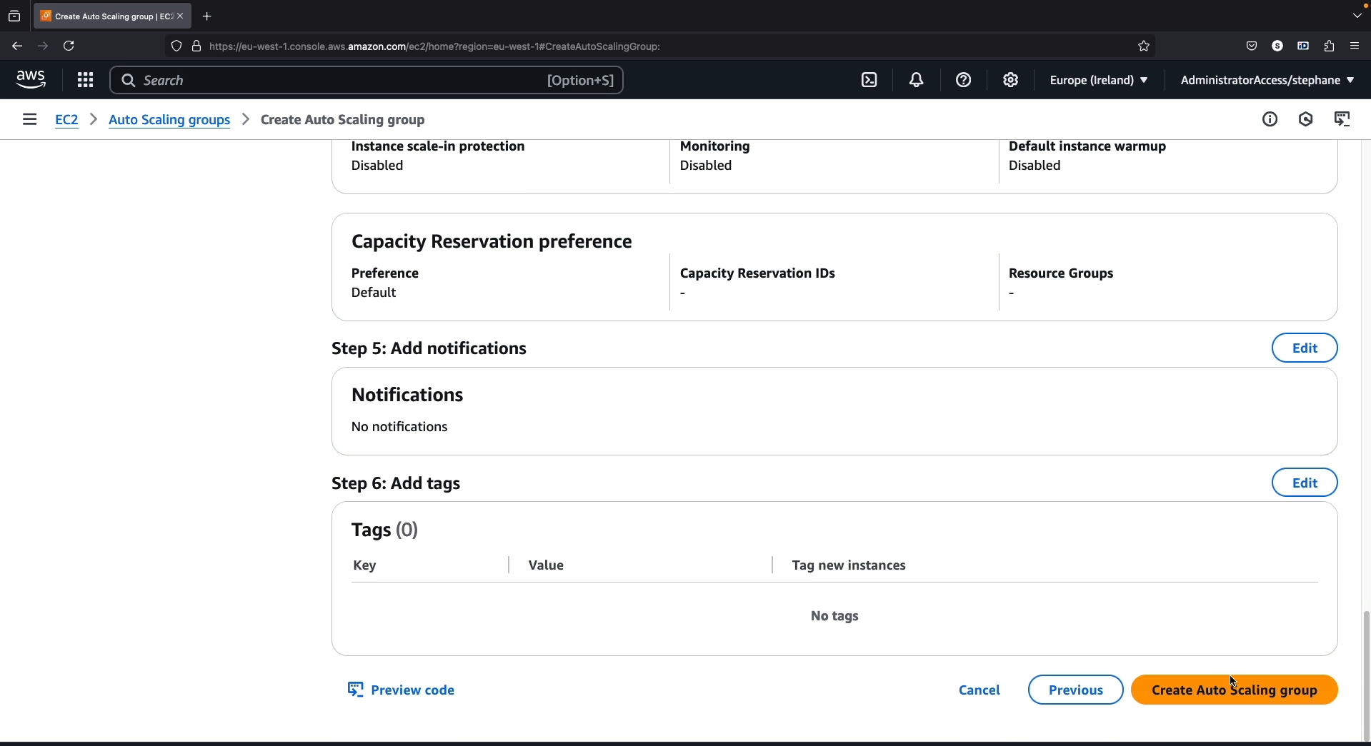

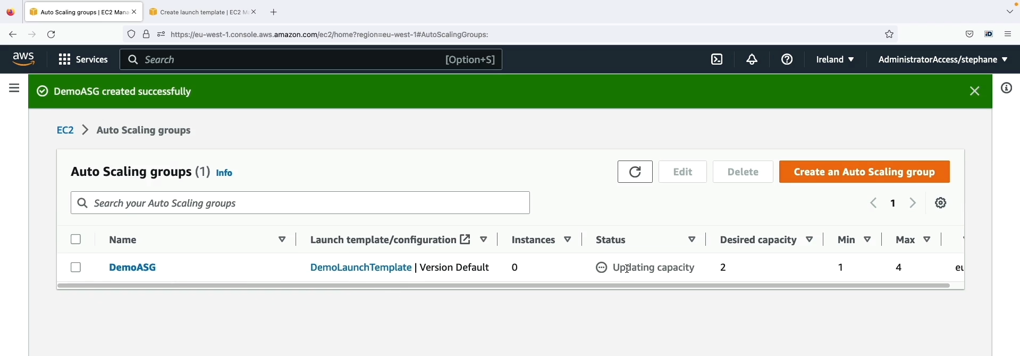

Step 1: Final step 🡪 review the ASG finally 🡪 click create Auto scaling group 🡪 ASG created successfully.

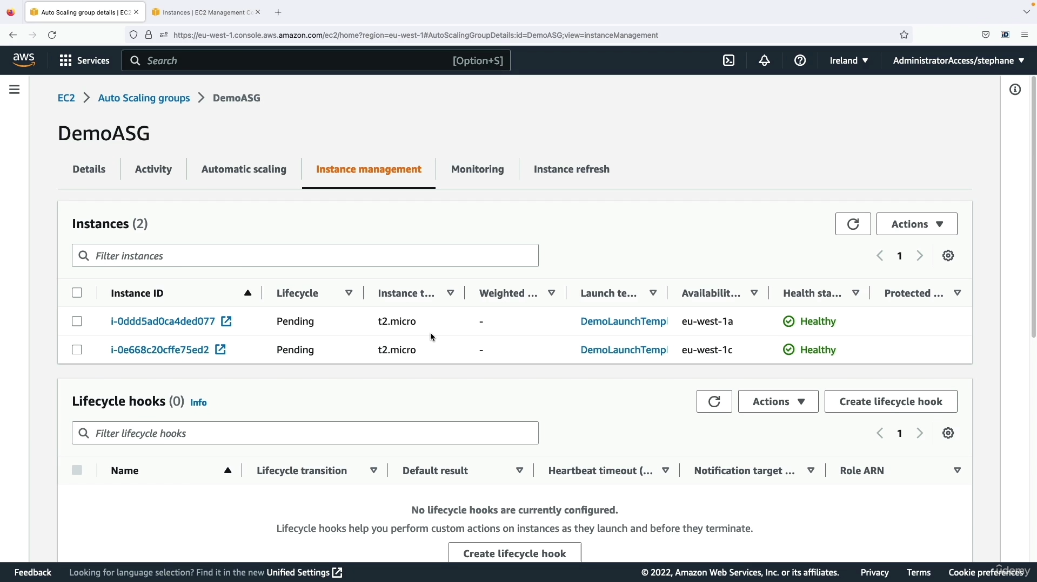

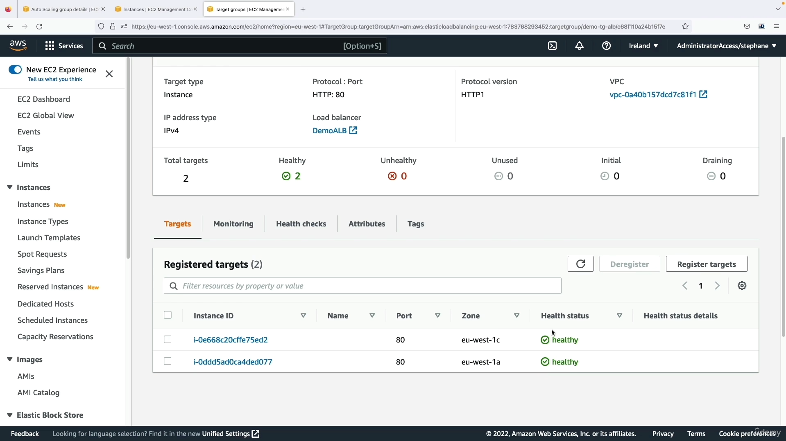

Step1 : Go to ASG setting 🡪 you will see two instances are created 🡪 because we put the maximum size as 2 instances 🡪 Health status 🡪 Healthy 🡪 means both the instances are working fine.

Step2: Load balancing setting 🡪 there also two instances will be there which are created by ASG 🡪 Health status 🡪 healthy.

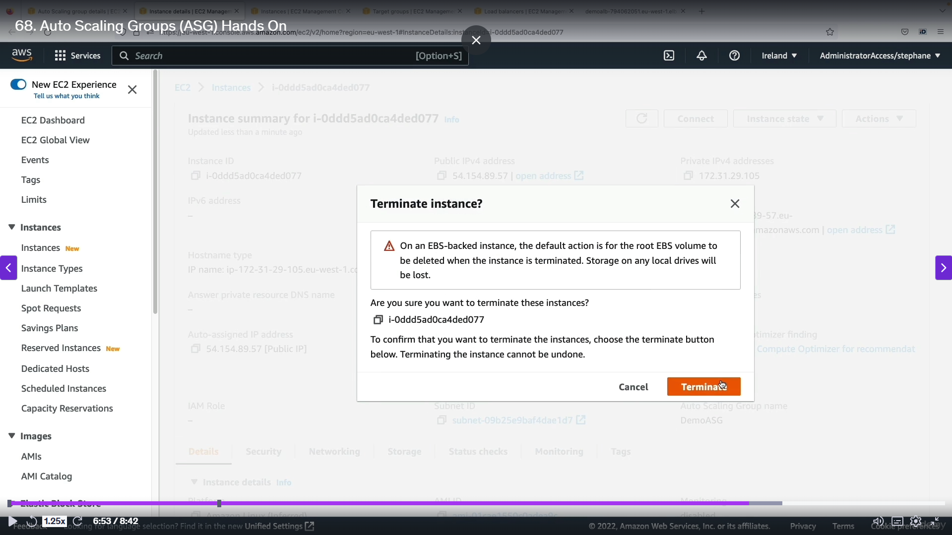

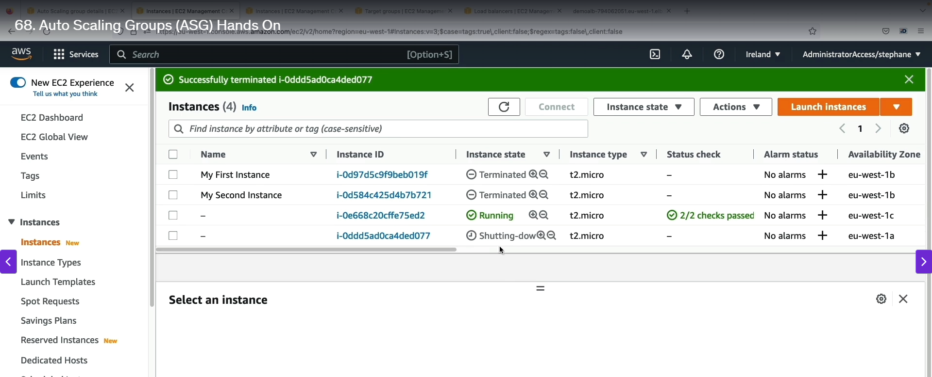

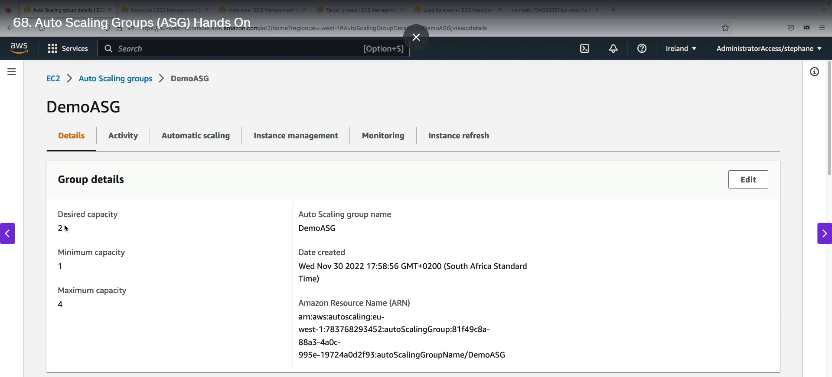

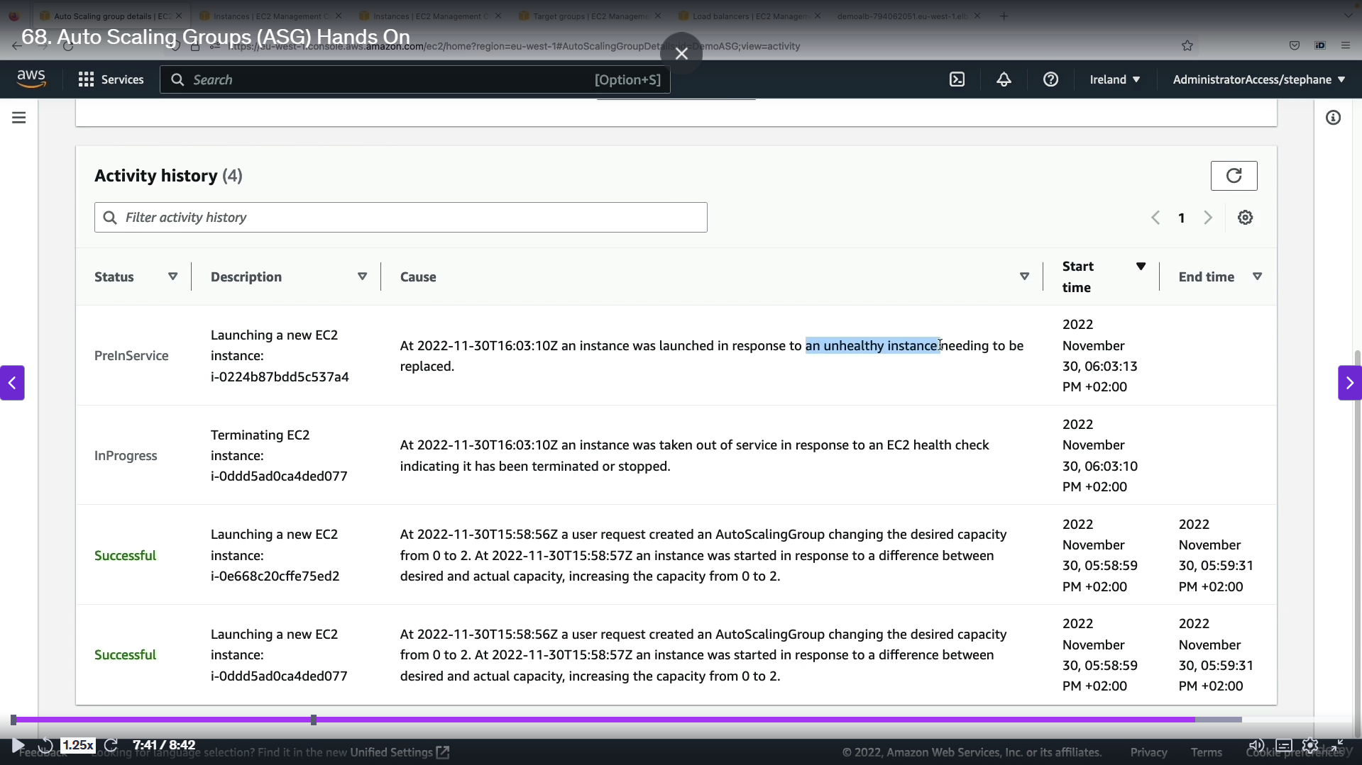

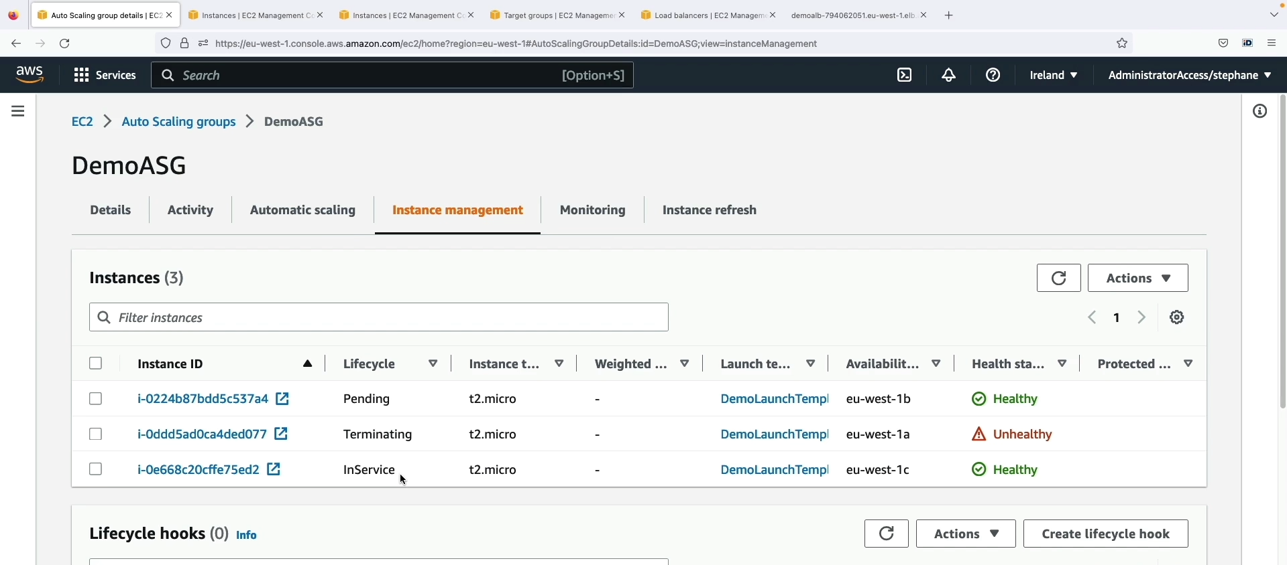

Step1: Terminate one instances in instances setting 🡪 one instance is shutting down 🡪 in both load balancing and in ASG 🡪 the terminated instances health become unhealthy.

Step 2: ASG come into play 🡪 we set the maximum instance is 2 🡪 so it will automatically create one instances with the same config 🡪 Which we will see in the activity history.

Step 3: In ASG page 🡪 three instances are there 🡪 one health status is unhealthy (terminated one) 🡪 one instances in Inservice (already working one) 🡪 One instances in pending (which was created by ASG just now).

* + 1. **Auto Scaling Groups (ASG) Strategies:**

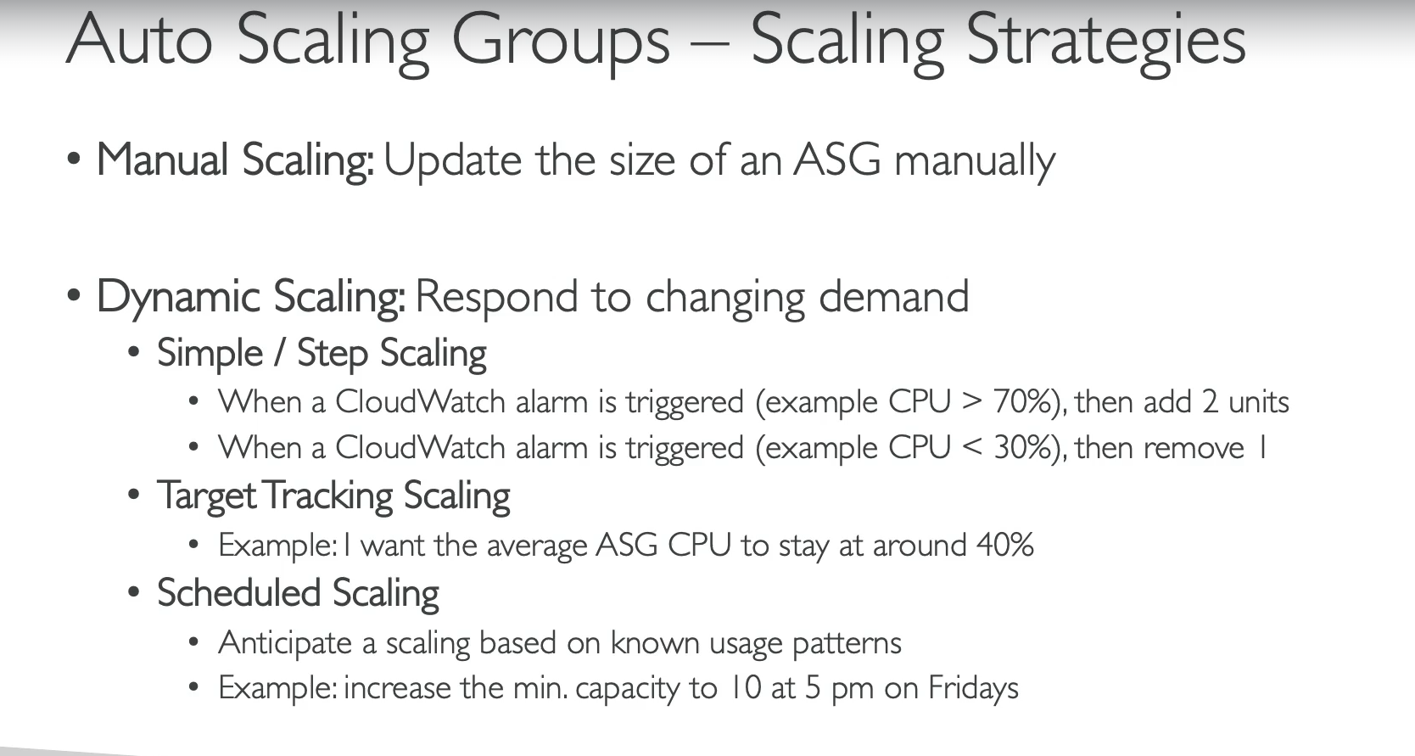

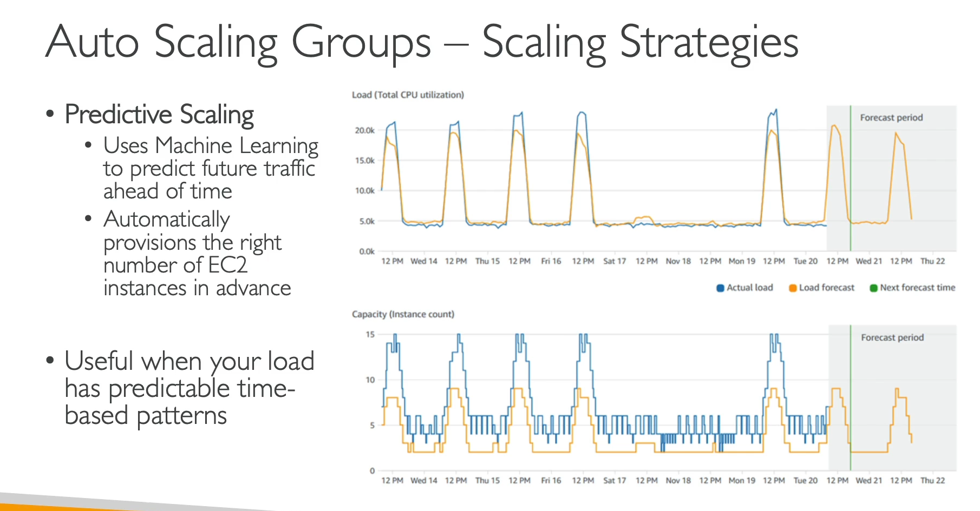

**Manual Scaling**

This is the most basic approach. With manual scaling, you **manually adjust the size** of your ASG. This means you directly change the desired capacity, such as from one instance to two, and the ASG will make the necessary changes.

**Dynamic Scaling**

This strategy allows your ASG to **automatically respond to changing demands** in real time. It's triggered by a metric, typically based on a CloudWatch alarm. There are different types of dynamic scaling policies:

* **Simple and Step Scaling:** This is a rule-based approach. You define a trigger and a fixed action. For example:
  + **Scale-out:** "If the average CPU utilization is above 70% for five minutes, add two instances."
  + **Scale-in:** "If the average CPU utilization is below 30% for ten minutes, remove one instance."
  + This is a good strategy when you know exactly what action you want the ASG to take in response to a specific metric.
* **Target Tracking Scaling:** This is the easiest and most recommended method. You set a target value for a specific metric, and the ASG automatically adjusts its capacity to maintain that target. For example:
  + You tell the ASG, "Keep the average CPU utilization at around 40%."
  + The ASG then handles all the scaling logic in the background to try and keep the metric at that target value.

**Scheduled Scaling**

This strategy is used when you **know a scaling event is going to happen ahead of time**. It's based on a predictable schedule or known usage patterns. For example:

* "Every Friday at 5:00 PM, increase the minimum capacity to 10 instances in anticipation of high traffic from a sporting event."
* This is perfect for predictable events like holiday sales or a weekly spike in traffic.

**Predictive Scaling**

This is an advanced strategy that uses **machine learning to predict future traffic** based on historical data.

* It analyzes past usage patterns (e.g., daily or weekly traffic spikes) to forecast when demand will increase.
* It then **provisions the right number of instances in advance** of the predicted traffic spike, ensuring your application is ready before the demand hits.
* Predictive scaling is an effective way to handle time-based patterns and provides a proactive, hands-off approach to scaling.
  + 1. **ELB & ASG Summary:**



